Library Management

This is a simple project for CSE-422 course (Coding practice) basing on .NET framework with C# programing langue and building by Visual Studio 2022.

# **Structure**

The project was built in MVC pattern including Models, Views, Controllers.

Models is a set of objects that existed in the project.

Views is a collection of html files that are displayed for users.

Controllers contains back-end functions or APIs that solve and response data from the Views.

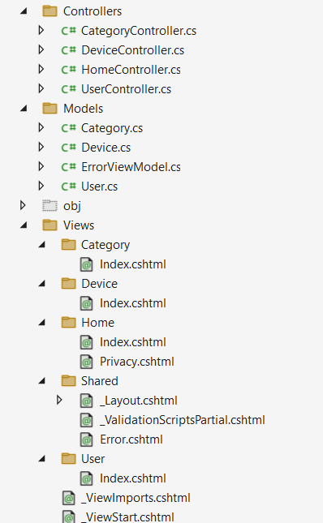

There are 3 classes: Category, Device, User which are created following the question of the assignment. Inside the 3 classes have all contribute with getter, setter and constructors for using in Controllers.

The project uses cshtml which is a combine between C# and HTML. All cshtml use dynamic css passed from _Layout.cshtml. User can map to another page by the controller of the object.

When loading pages, the displayed data is passed through controllers. Because the project don’t have database, all the list are static in the controller.

All styles in the project is implementation from Bootstrap.

# **Application**

The Home page is a default .NET project page, but it was added some new tabs (Category, Device, User) following the lab question.

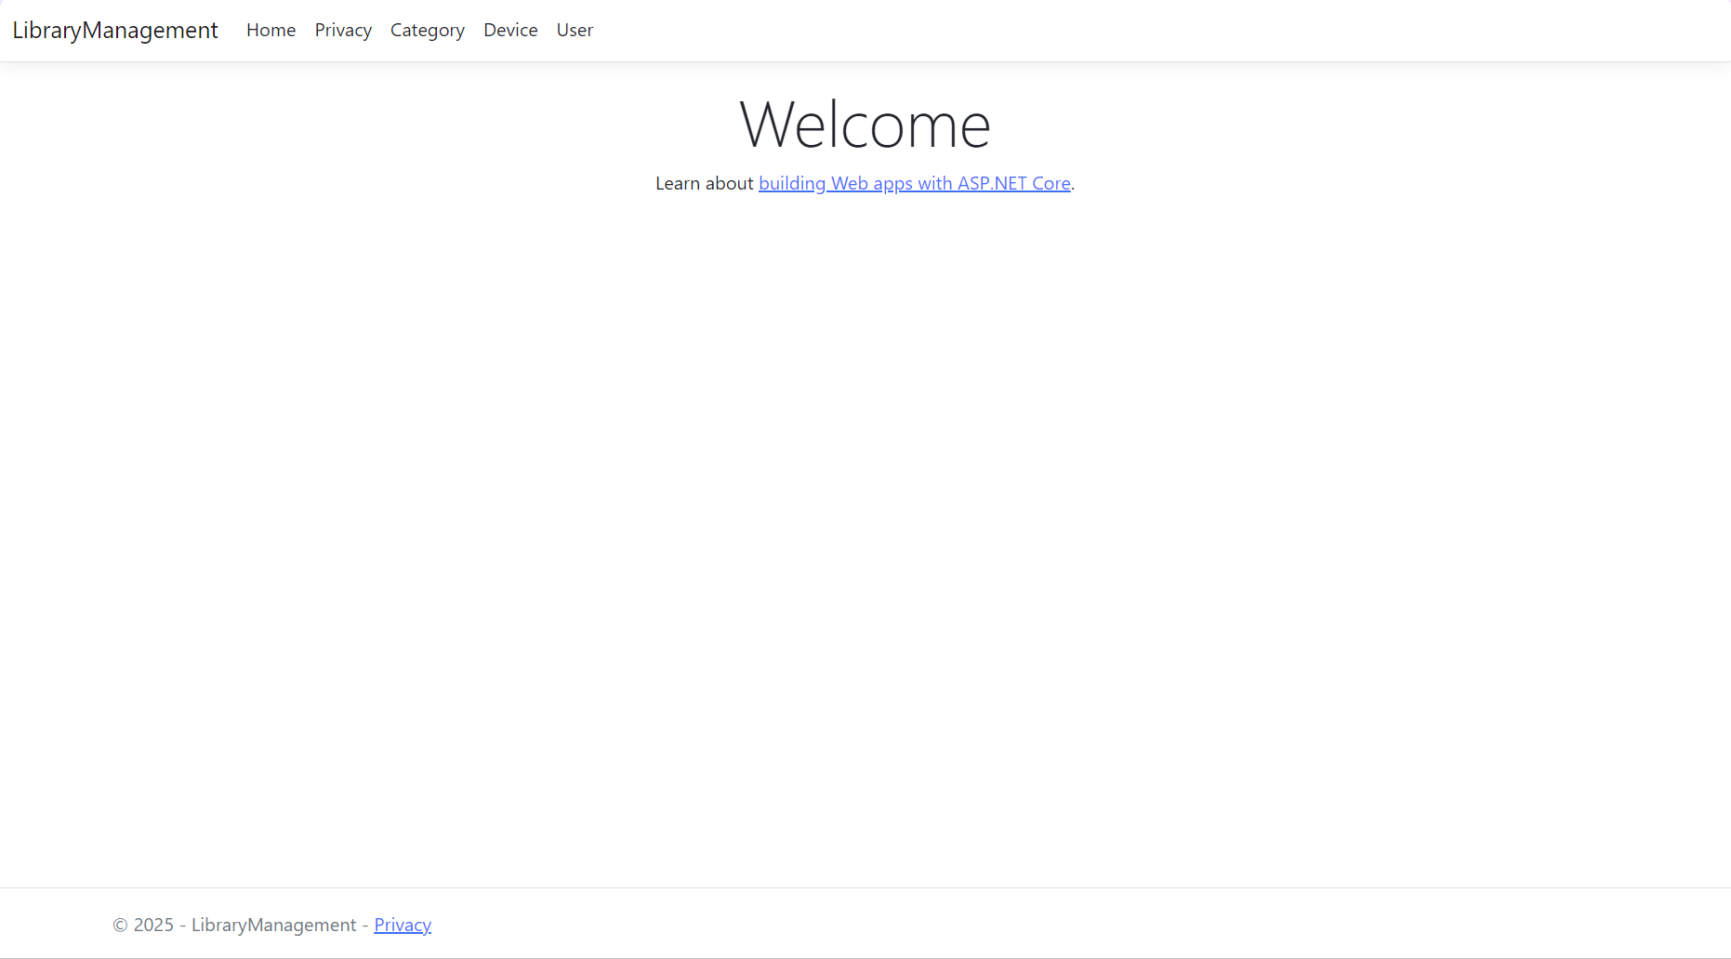

The Category page is simple and user-friendly with basic functionalities: Create, Read, Delete, Edit

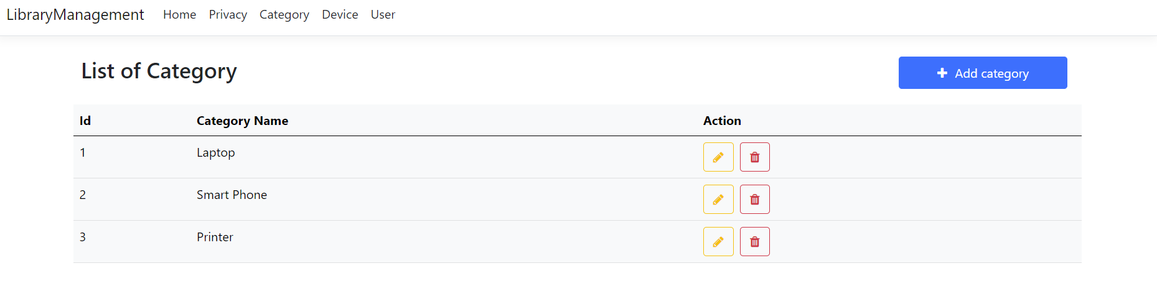

After clicked the add category button, it will show the modal for user using Bootstrap modal.

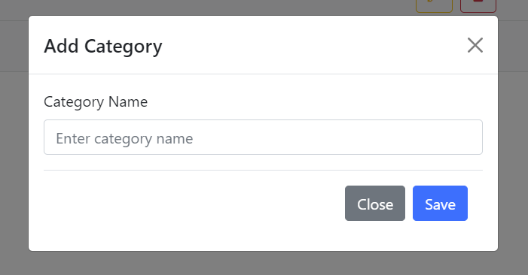

Filled in the input and then click Save, the CategoryController will get the name from the input, then create a new category with the auto increase id.

Click on the yellow pencil for edit information in the category, it is same with add function but the existed information will be shown in the input. It works by get the Category id from the hidden input, then passing to the Edit method in Category Controller. It use the Id to find the existed category in the Category list. Finally, update all fields in that by the new information.

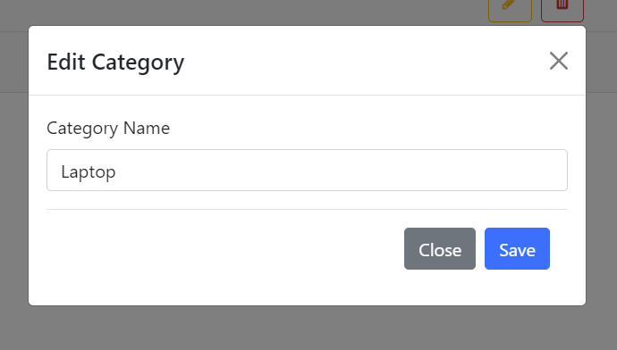

Click on the red trash can to delete the category in the list, it pass the id of the category to Delete method in Category controller, then remove the category with that id in the category list.

The Device and User basis function is like the Category.

The Device page has more than two function: Search by name and Filter by status.

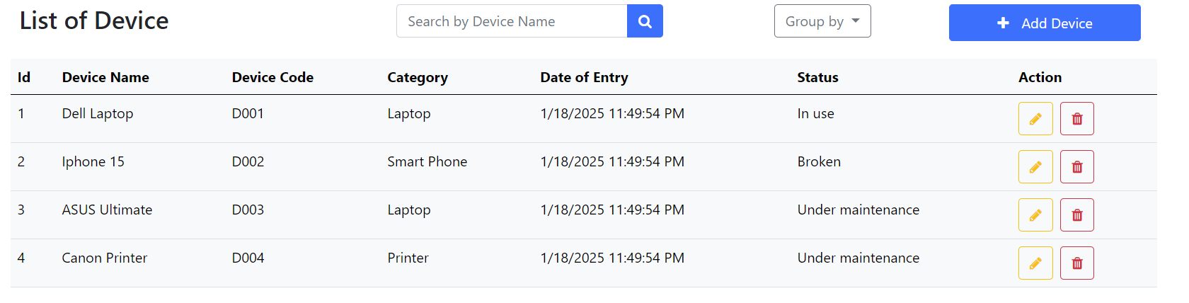

It simply passes the key (Device Name, Status) to the Filter method in the controller, then pass a new Filtered List to the Index to reload the list in page which is filtered by iterating the current list and get the object has fields equals the key.